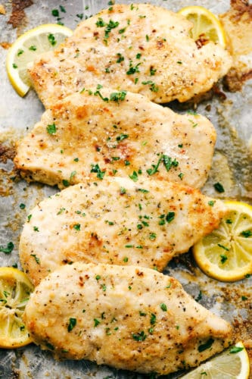
Baked Parmesan Garlic Chicken
Prep time 5 min Cook time 20 min
4 Servings
Ingredients
4 boneless skinless chicken breasts
1 package dry Italian dressing packet
1 tsp garlic powder
½ cup grated parmesan cheese
¼ cup breadcrumbs
Directions
- Preheat oven to 400 degrees.
- Mix together the Italian dressing mix, parmesan cheese, breadcrumbs and garlic powder.
- Wash chicken and while still damp, coat them with the cheese mixture.
- Bake chicken breasts in shallow dish for 15 to 19 minutes convection oven (20 to 25 minutes oven) or until no longer pink.
Notes
For 2 servings, split mixture before adding cheese. Use ¼ cup of cheese for each serving of two.

